Exercises | Time / Reps | Description
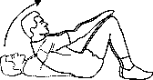  Crunches | 2 minutes / until fatigue | Lay on back knees bent. Using abdominal muscles lift shoulder off of the ground reaching for knees.
Side Planks  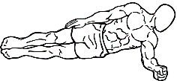 | 1 minute or until fatigue | Lay on your side. Using elbow for support lift body off of ground so only feet and elbow are touching the ground
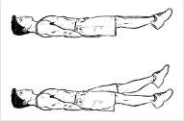  Flutter kicks | 1 minute or until fatigue | Lay on back and lift legs slightly off floor supporting your back with arm. Then slowly kick legs in small flutter pattern.
Scissors  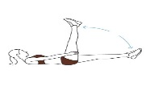 | 1 minute or until fatigue | Lay on back and lift legs slightly off floor supporting your back with arms. Then slowly kick legs in large flutter pattern.
Knee Crunches  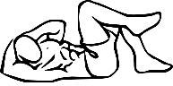 | 1 minute or until fatigue | Lay on back and lift head, shoulders into slight crunch position supporting head. Bring right knee to left elbow then left knee to right elbow and alternate.
Planks  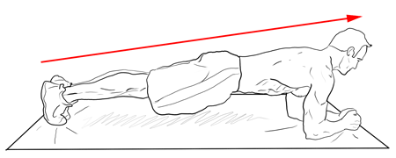 | 1 minute or until fatigue | Prone position lift body off of ground supporting weight with only elbows and toes holding abdominal muscles tight so body is in straight line.
Advanced planks  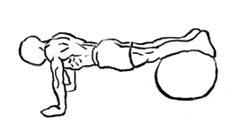 | 1 minute or until fatigue | Prone position lift body off of ground supporting weight with hands and shins / toes on ball / chair holding abdominal muscles tight so body is in straight line.
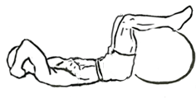  Advanced crunches | 1 minute or until fatigue | Supine position with legs on ball / chair supporting head and neck with hands lift head and shoulder as high as possible of ground using abdominal muscles.
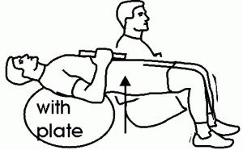  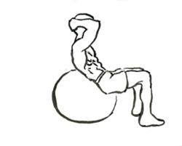  Balance Crunches | 1 minute or until fatigue | Balancing on ball supporting head and neck with hands. Roll forward balancing shoulders and back on ball using abdominal muscles to create a bridge. Use weight plate when you can complete one minute, not fatigued.
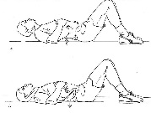  Pelvic tilts | 1 minute or until fatigue | Supine position with knees bent arch lower back with shoulders and pelvis on the ground then flatten back to ground pushing belly button to the ground.

