Exercise | Time / Reps | Description
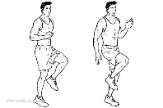  High knees | 30 seconds | Walk in place bringing knees as high as possible
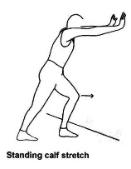  Achilles Stretch | 15 Seconds Each Leg | Face wall, place left foot back so you are in runner position. Palms on the wall in front of you, bend right leg keeping left foot and heel on the ground push forward with back foot
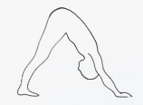  Downward dog | 15 Seconds Each Leg | Start in push up position with palms and feet on floor. Raise your bottom up until your palms and heels are flat on the floor and you are in a downward V position.
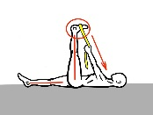  Lateral Ankle stretching | 15 Seconds Each Leg | Stand with both feet shoulder width apart. Then slowly roll your right foot onto the outside part of your foot. You should feel a mild stretch in the lateral ankle
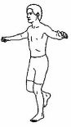  Static Balance | 30 seconds | Lift one foot off the ground standing on the other hold and balance. Once you can do this with your eyes open try doing it with your eyes closed.
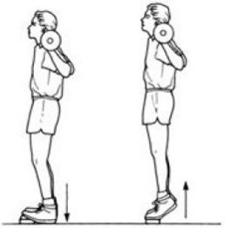  Toe Lifts | 15 Neutral  15 Outward  15 Inward | Stand erect with your feet shoulder width apart. Heels and toes parallel to each other. Then slowly rise onto your toes reaching as high as possible to the sky. Repeat 15 reps then rotate feet 45 degrees outward and repeat and then repeat with feet 45 degrees inward.

